**Experiment No 1**

**Name:Ajinkya Patil**

**Div:D15B**

**Roll No.:46**

**Batch C**

**Aim: To understand the benefits of Cloud Infrastructure and Setup AWS Cloud9 IDE, Launch AWS Cloud9 IDE and Perform Collaboration Demonstration.**

**Theory:**

AWS Cloud9 is a cloud-based integrated development environment (IDE) that lets you write, run, and debug your code with just a browser. It includes a code editor, debugger, and terminal. Cloud9 comes prepackaged with essential tools for popular programming languages, including JavaScript, Python, PHP, and more, so you don’t need to install files or configure your development machine to start new projects. Since your Cloud9 IDE is cloud-based, you can work on your projects from your office, home, or anywhere using an internet-connected machine. Cloud9 also provides a seamless experience for developing serverless applications enabling you to easily define resources, debug, and switch between local and remote execution of serverless applications. With Cloud9, you can quickly share your development environment with your team, enabling you to pair program and track each other's inputs in real time.

Benifits:

CODE WITH JUST A BROWSER

AWS Cloud9 gives you the flexibility to run your development environment on a managed Amazon EC2 instance or any existing Linux server that supports SSH. This means that you can write, run, and debug applications with just a browser, without needing to install or maintain a local IDE. The Cloud9 code editor and integrated debugger include helpful, time-saving features such as code hinting, code completion, and step-through debugging. The Cloud9 terminal provides a browser- based shell experience enabling you to install additional software, do a git push, or enter commands.

CODE TOGETHER IN REAL TIME

AWS Cloud9 makes collaborating on code easy. You can share your development environment with your team in just a few clicks and pair program together. While collaborating, your team members can see each other type in real time, and instantly chat with one another from within the IDE.

BUILD SERVERLESS APPLICATIONS WITH EASE

AWS Cloud9 makes it easy to write, run, and debug serverless applications. It preconfigures the development environment with all the SDKs, libraries, and plug-ins needed for serverless development. Cloud9 also provides an environment for locally testing and debugging AWS Lambda functions. This allows you to iterate on your code directly, saving you time and improving the quality of your code.

DIRECT TERMINAL ACCESS TO AWS

AWS Cloud9 comes with a terminal that includes sudo privileges to the managed Amazon EC2 instance that is hosting your development environment and a preauthenticated AWS Command Line Interface. This makes it easy for you to quickly run commands and directly access AWS services

START NEW PROJECTS QUICKLY

AWS Cloud9 makes it easy for you to start new projects. Cloud9’s development environment comes prepackaged with tooling for over 40 programming languages, including Node.js, JavaScript, Python, PHP, Ruby, Go, and C++. This enables you to start writing code for popular application stacks within minutes by eliminating the need to install or configure files, SDKs, and plug-ins for your development machine. Because Cloud9 is cloud-based, you can easily maintain multiple development environments to isolate your project’s resources.

**Steps:**

**1. Login with your AWS account.**

**2. Navigate to Cloud 9 service from Developer tools section as below:**

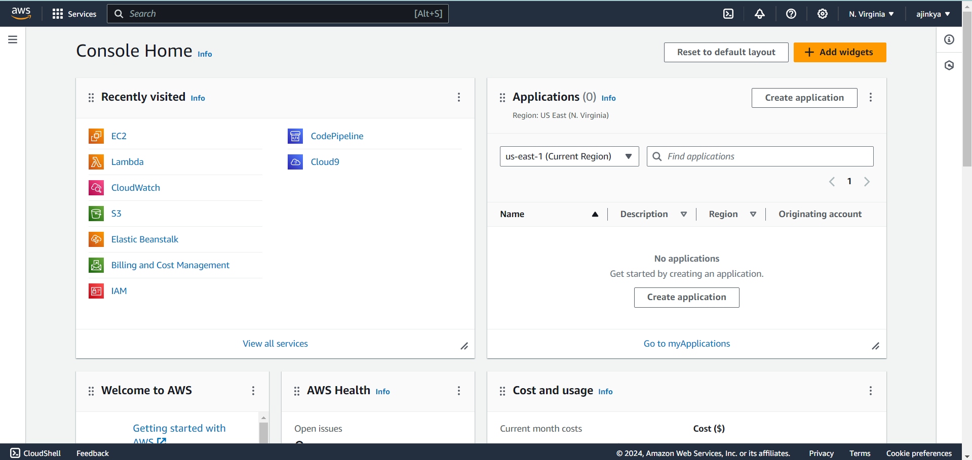

**3. Click on Create Enviornment :**

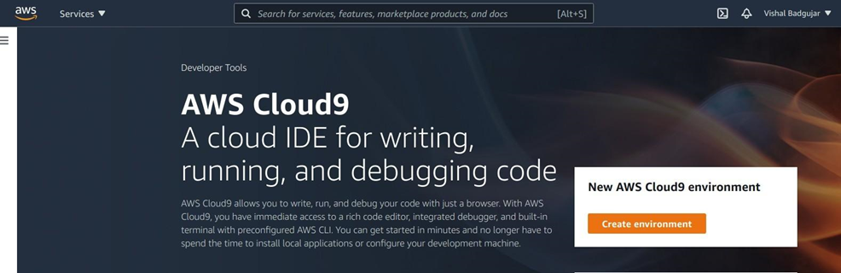

**4. Provide name for the Enviornment (WebAppIDE) and click on next.**

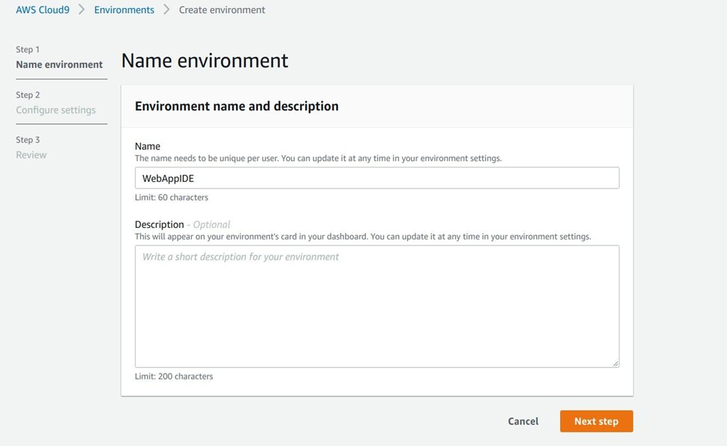

**5. Keep all the Default seetings as shown in below:**

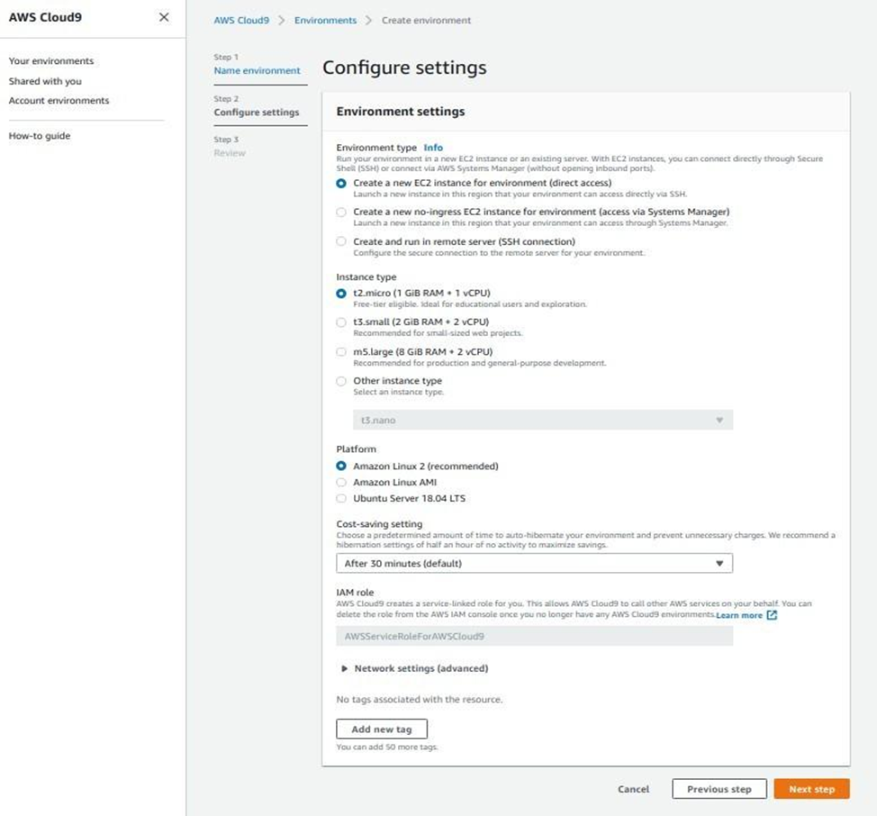

**6. Review the Enviornment name and Settings and click on Create Enviornment:**

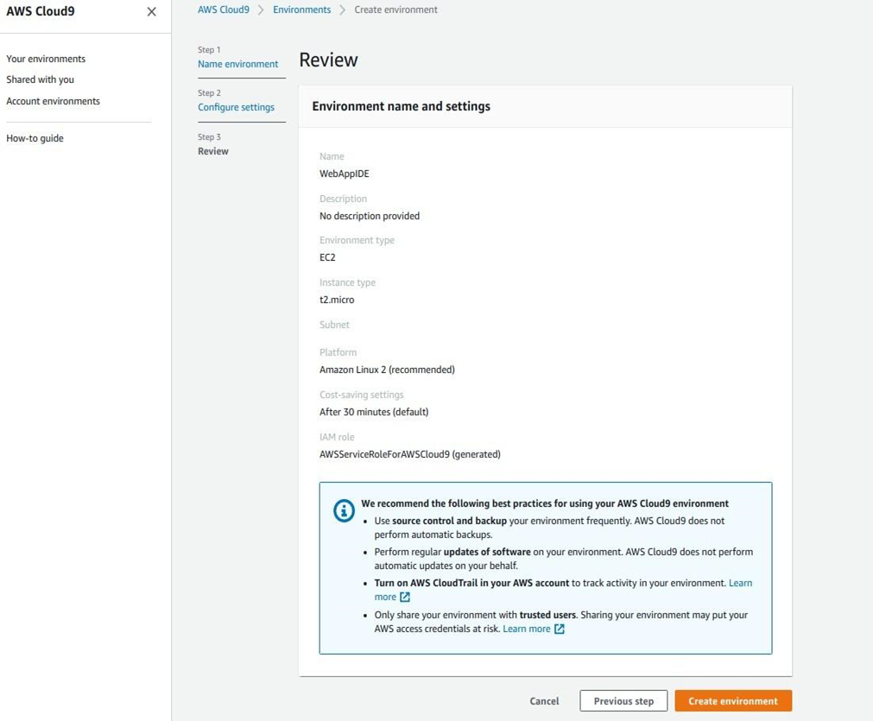

**7. Till that time open IAM Identity and Access Management in order to Add user In other tab.**

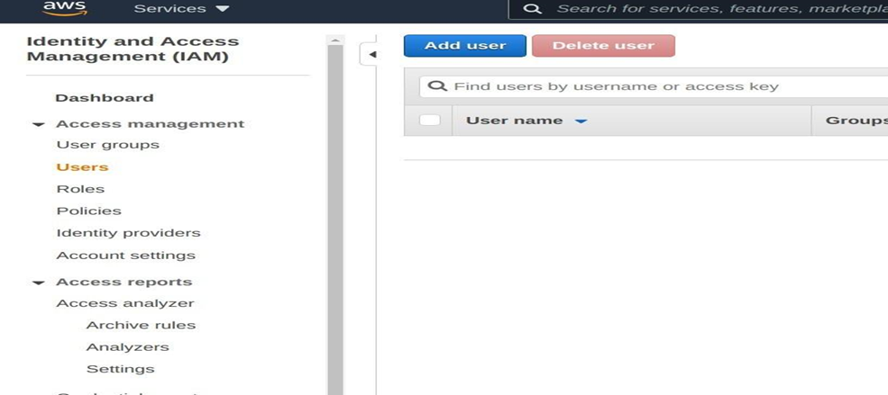

**8. Add user provide manual password if you want and click on Next permission tab.**

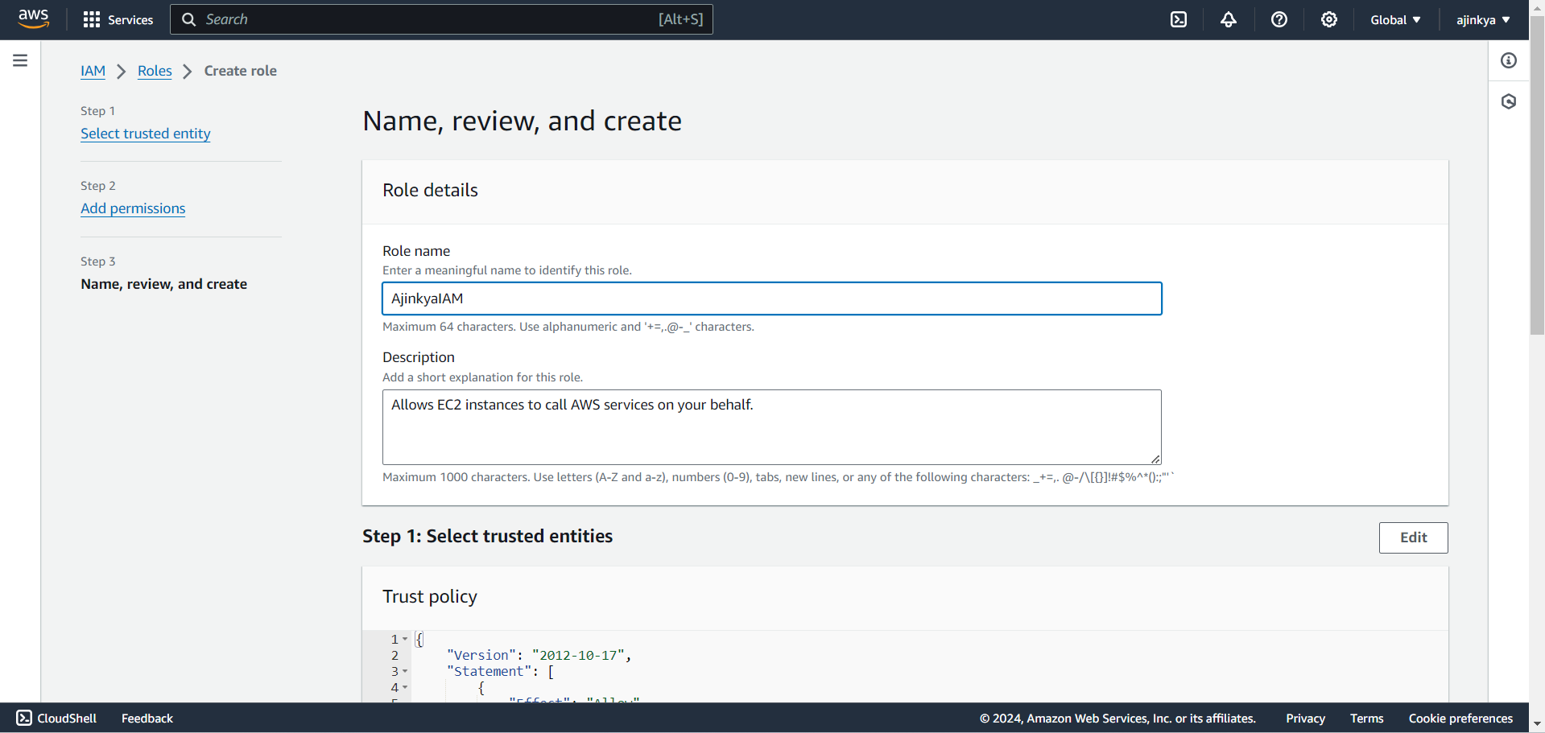

**9. Click on Create group**

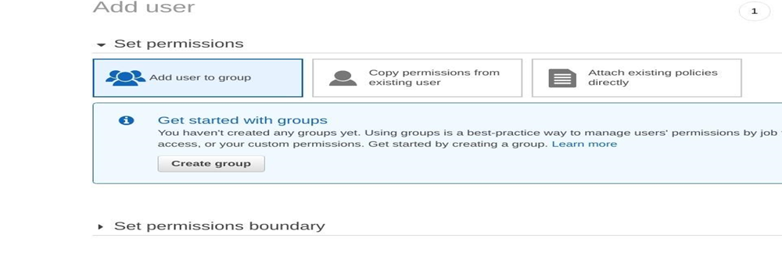

**10. Provide group name and click on create group.**

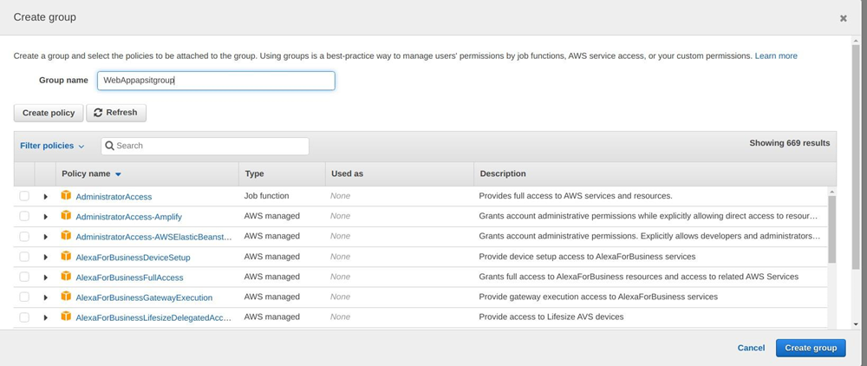

**11. After that group is created click on next if u want to provide tag else click on Review for user settings and click on create user as shown in fig.**

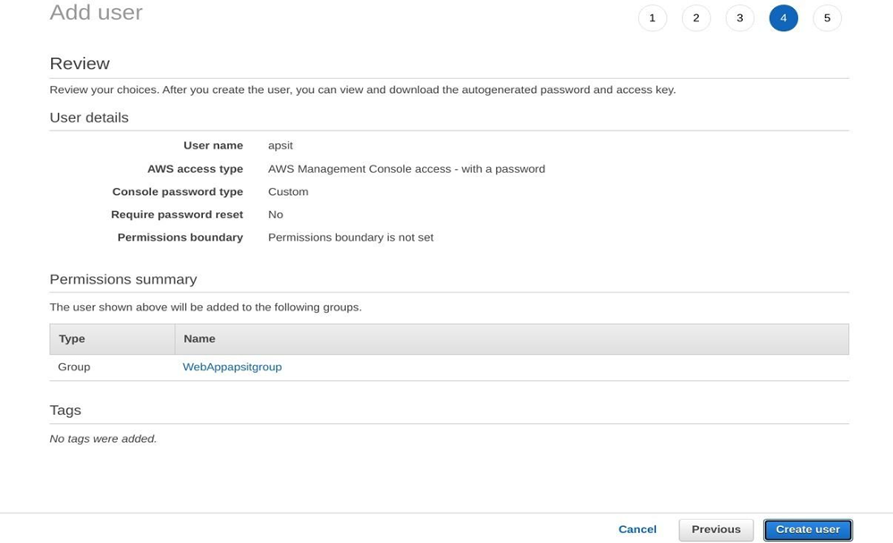

**12. Now close that window and Navigate to user Groups from left pane in IAM.**

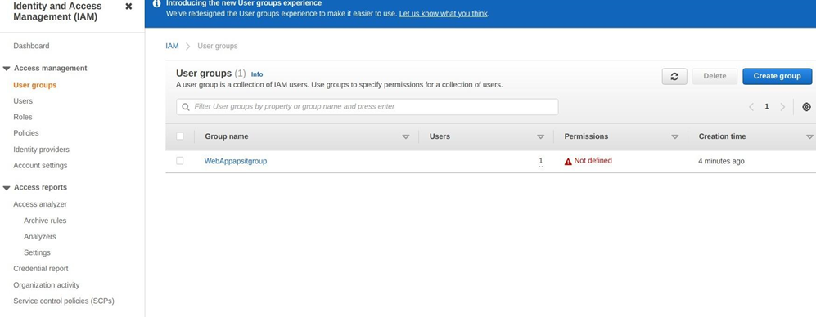

**13. click on your group name which you have created and nevigate to permission tab as shown:**

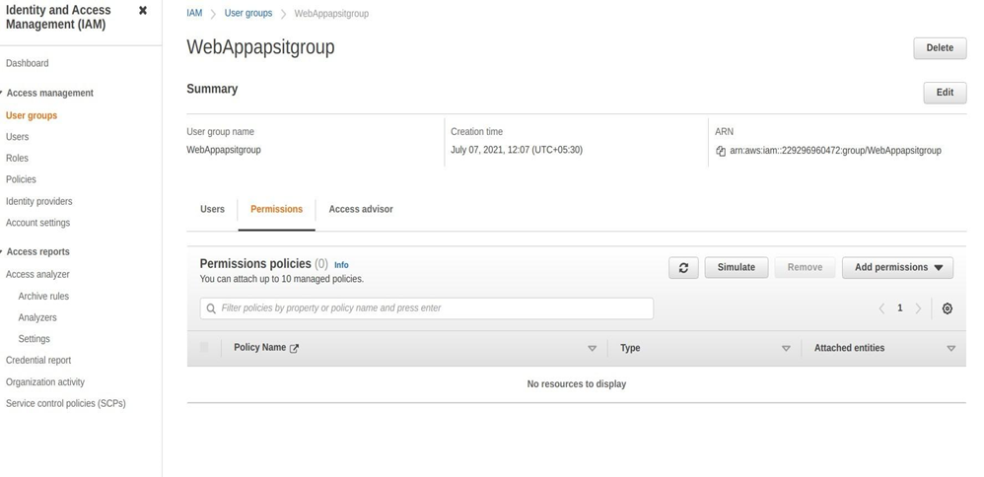

**14. Now click on Add permission and select Attach Policy after that search for Cloud9 related policy and select Awscloud9EnviornmentMember policy and add it.**

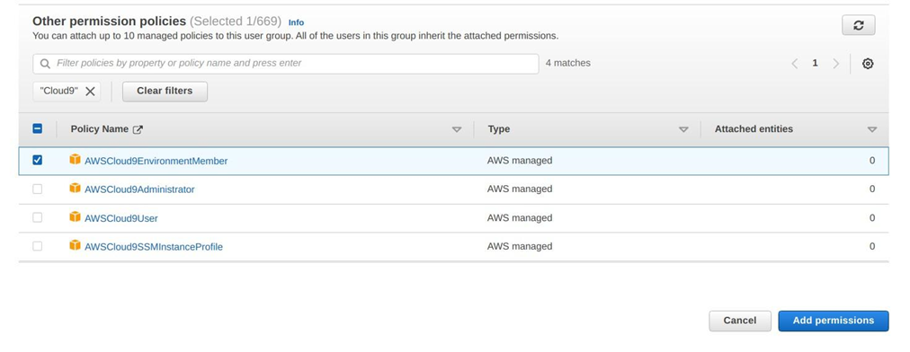

**15. now we move towards our cloud9 IDE Enviornment tab it shows as shown :**

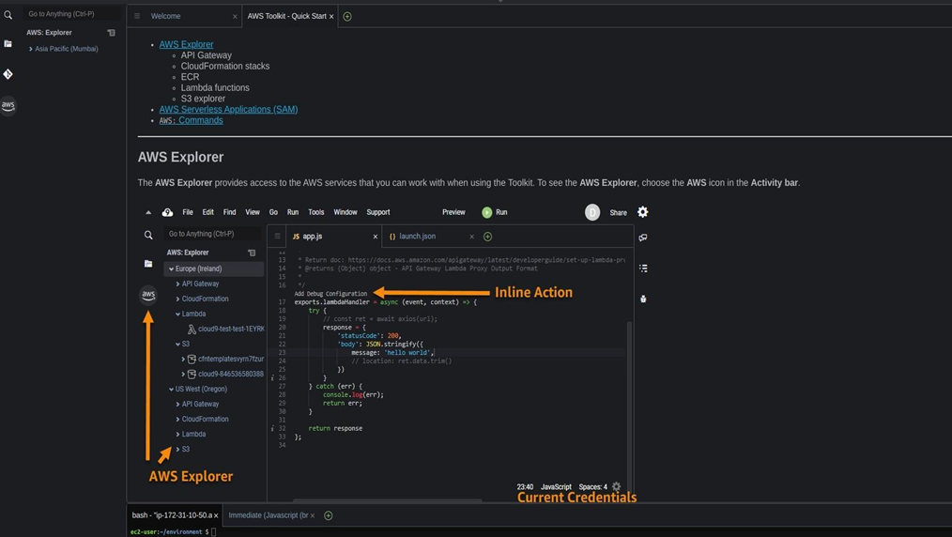

**16. If you check at bottom side Cloud9 IDE also giving you and aws CLI for command operations: as we here checked git version, iam user details and so on...**

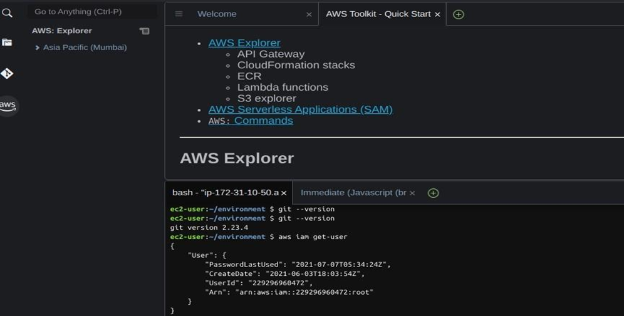

**17. Now we will setup collaborative enviornment Click on File you can create new file or choose from template, here m opting html file to collaborate.**

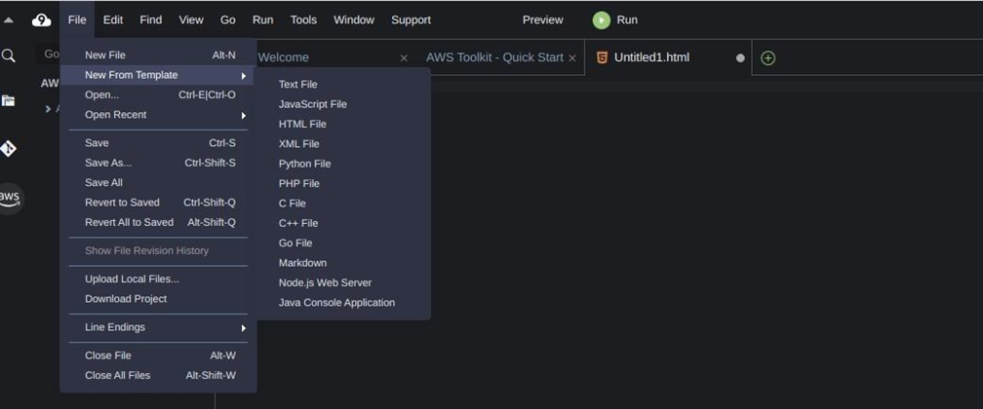

**18. Edit html file and save it**

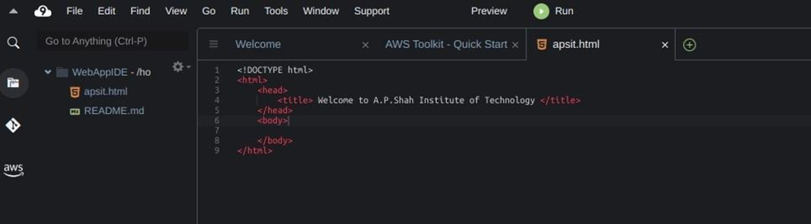

**19. now in order to share this file to collaborate with other members of your team click on Share option on Roght Pane and username which you created in IAM before into Invite members and enable persmission as RW (Read and Write) and click on Done. Click OK for Security warning.**

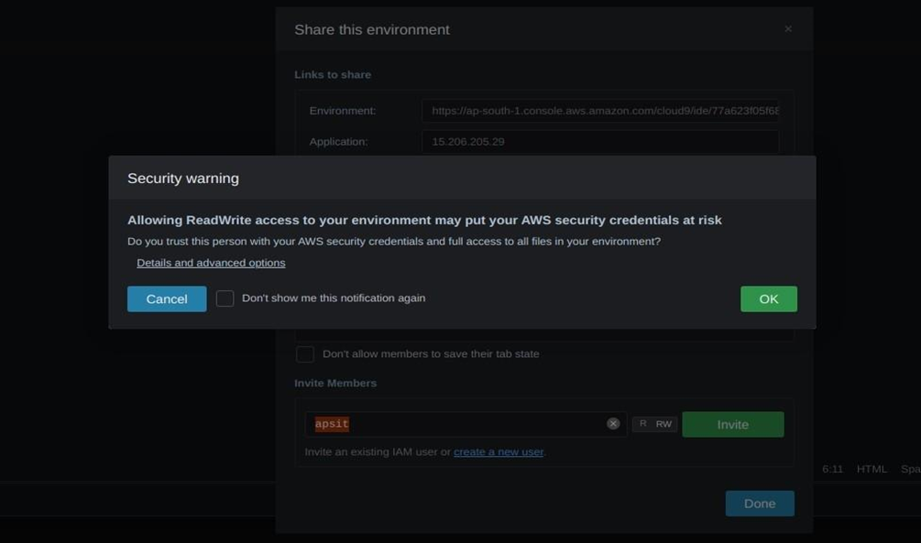

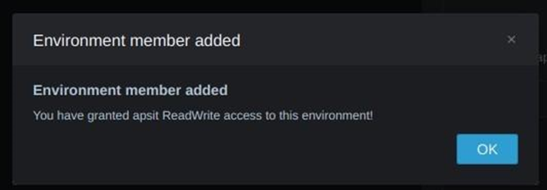

**20. Now Open your Browsers Incognito Window and login with IAM user which you configured before.**

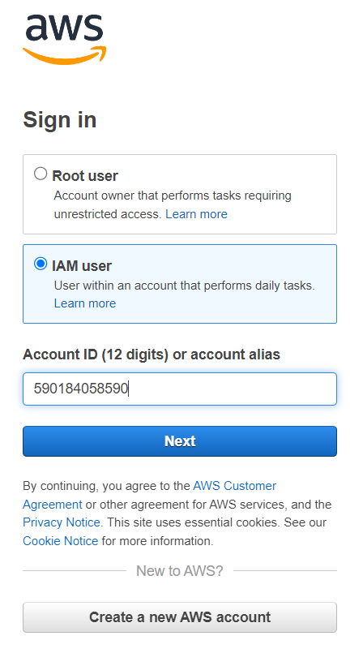

**21. After Successful login with IAM user open Cloud9 service from dashboard services and click on shared with you enviornment to collaborate.**

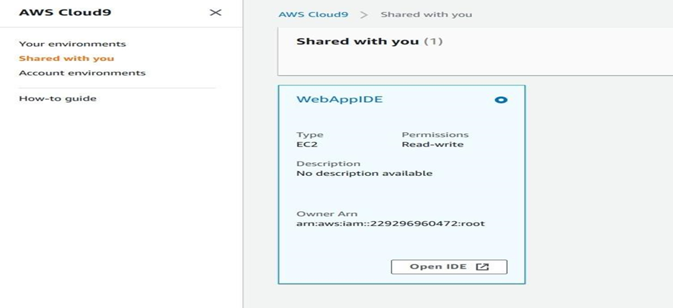

**22. Click on Open IDE you will same interface as your other member have to collaborate in real time, also you all within team can do group chats as shown below:**

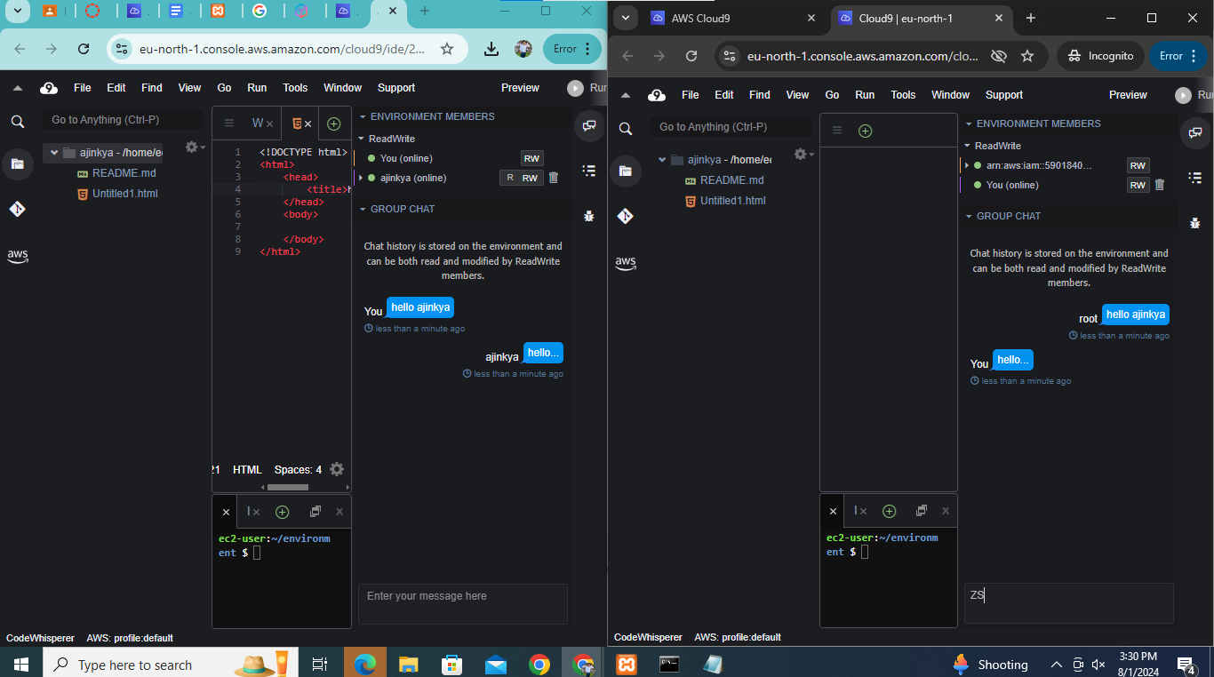

**23. you can also explore settings where you can update permissions of your temmates as from RW to R only or you can remove user too.**

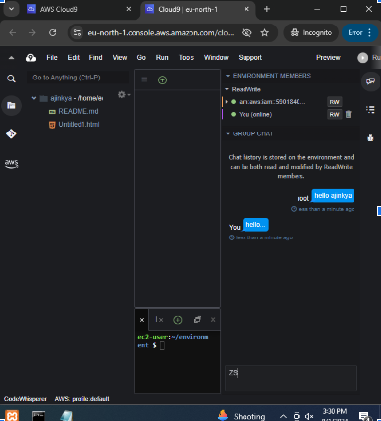

**For more info related to AWS-Cloud 9 you all can refer following Docs.**

**https://docs.aws.amazon.com/cloud9/latest/user-guide/aws-cloud9-ug.pdf**

**Conclusion:**

1. Benefits of Cloud Infrastructure: Cloud infrastructure provides scalability, flexibility, and cost-efficiency, allowing businesses to dynamically allocate resources, optimize performance, and reduce infrastructure management overhead.

2. AWS Cloud9 IDE for Collaboration: AWS Cloud9 IDE offers real-time collaboration features, enabling teams to work together seamlessly on code development, debugging, and testing within a cloud-based environment, enhancing productivity and remote teamwork.